**MySQL Workbench ER Diagram**

**To generate an ER diagram from MySQL Workbench**

1. Launch MySQL Workbench



1. Click on the Local instance MySQL icon

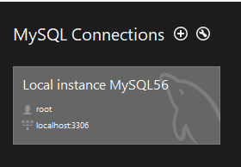

1. Enter the database password

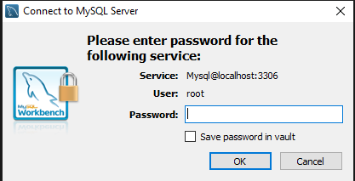

1. Click on Database, select Reverse Engineer

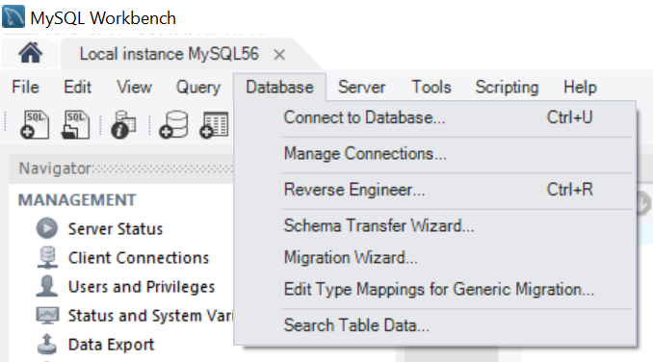

1. On the Set Parameters UI click the Next button

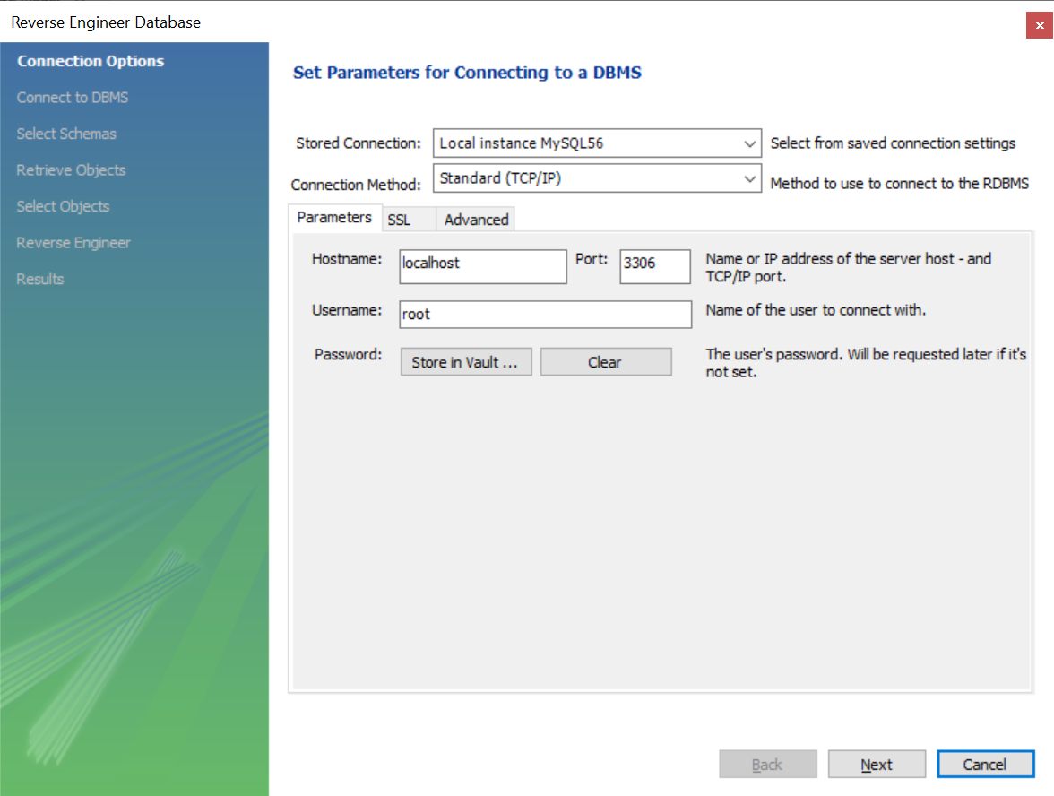

1. On the Connect to DBMS UI click the Next button

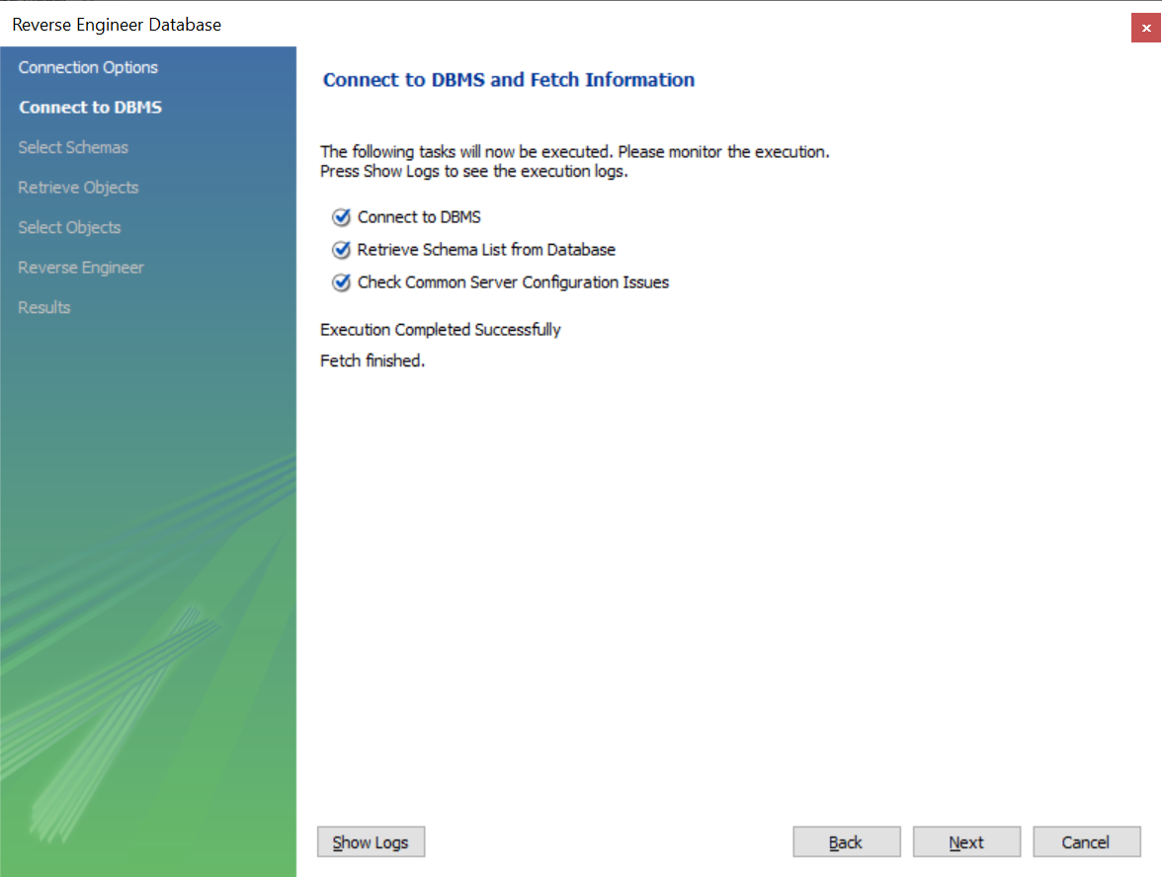

1. On the Select Schema UI select the database (e.g. hospital), click the Next button

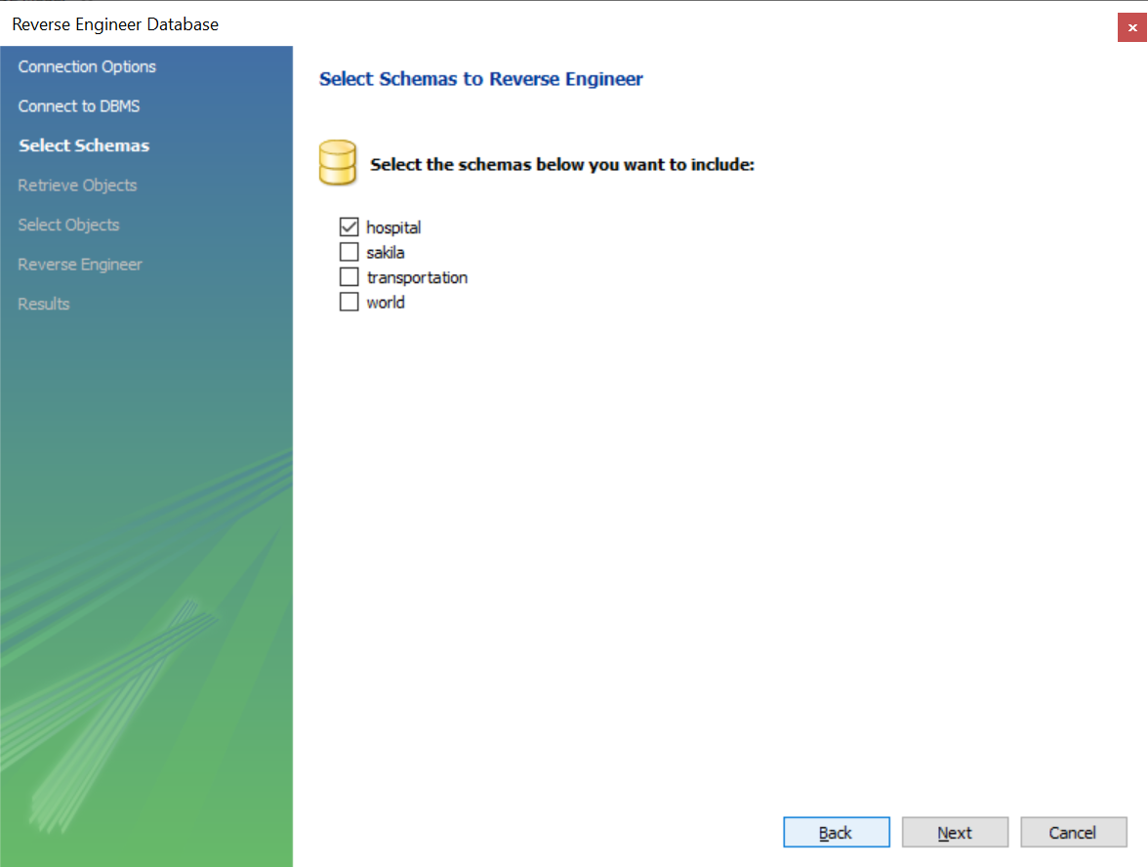

1. On the Retrieve and Reverse UI click the Next button

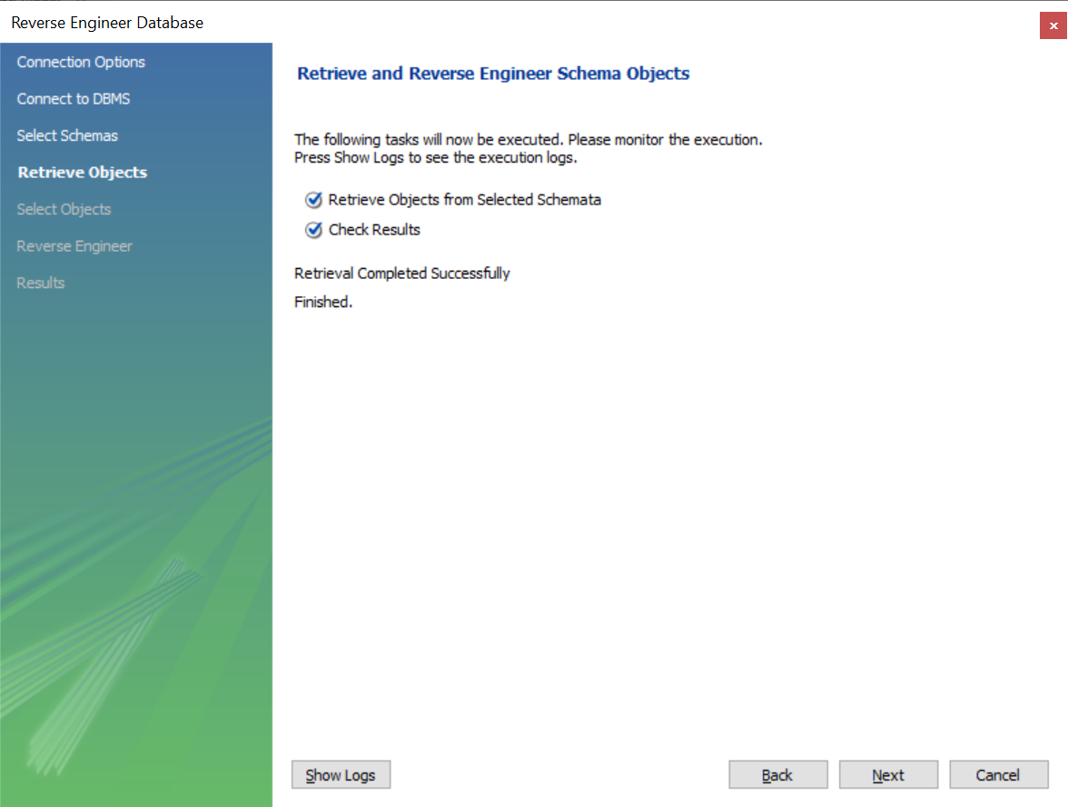

1. On the Select Objects UI click the Execute button

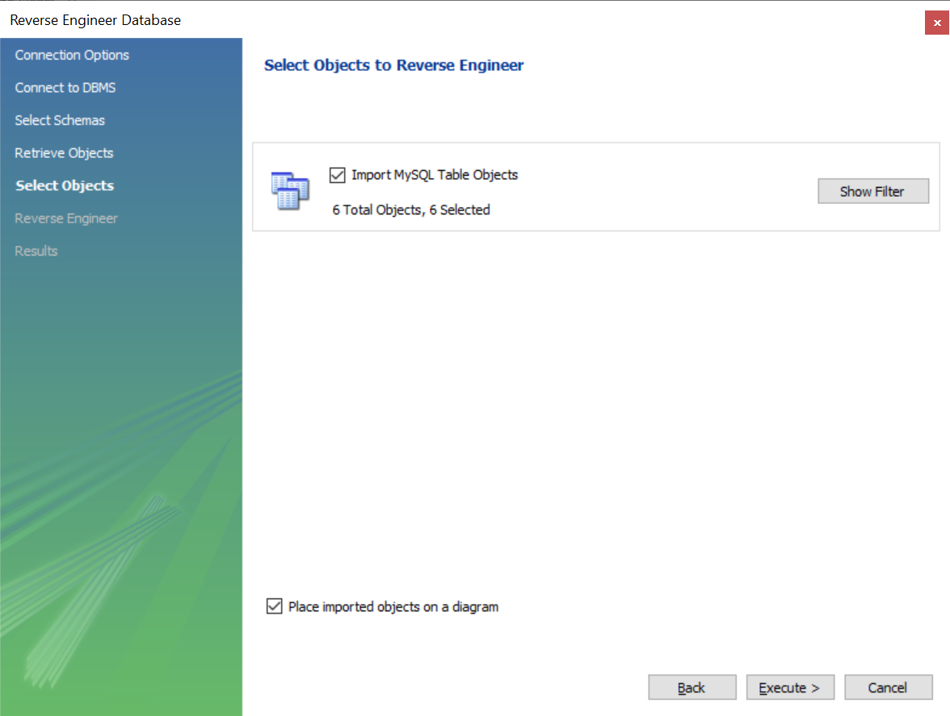

1. On the Reverse Engineering Progress UI click the Next button

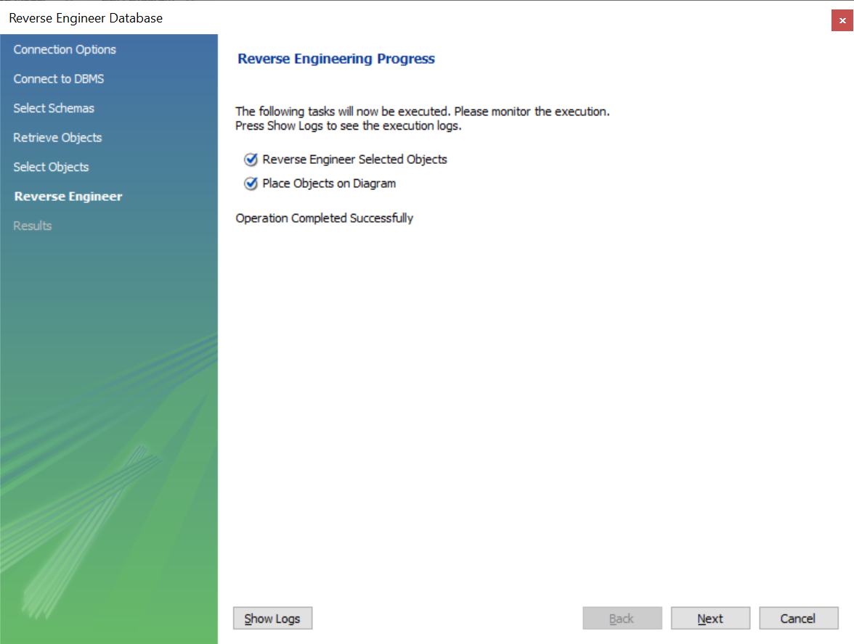

1. On the Reverse Engineering Results UI click the Finish button

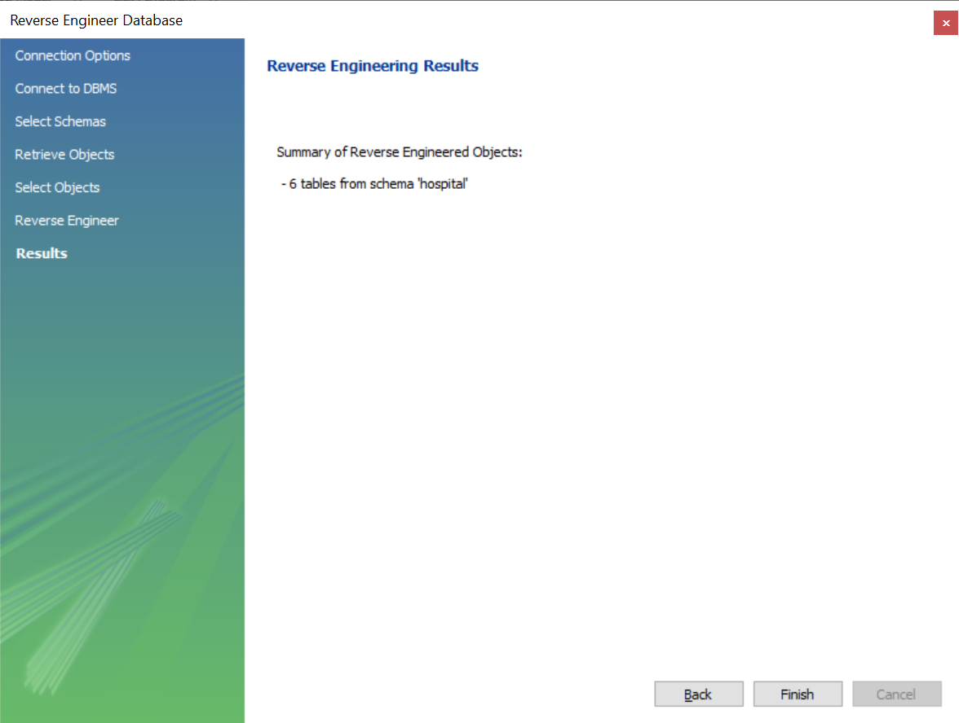

1. Click File🡪Save Model As

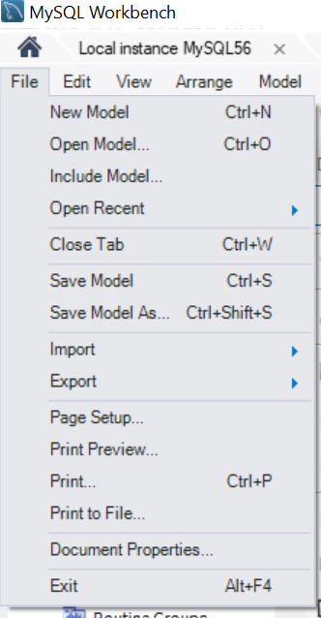

1. Enter student first name, last name, assignment number, and ERDiagram. File extension should be .mwb.

